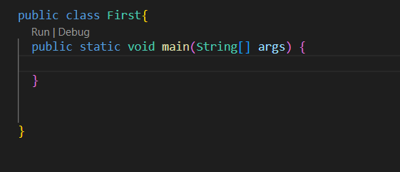

**Actual meaning of static**

here this is also a function, but as we can see this is a static function. Static means which do not need any objects to execute, they can be called even inside the classes.

For example

If we take the human as a class, then the population variable will be static because the population of all the humans do not depend upon any particular Object of human class

So it’s only natural that one static function can call another static function only

We can not call the non static function from the static function

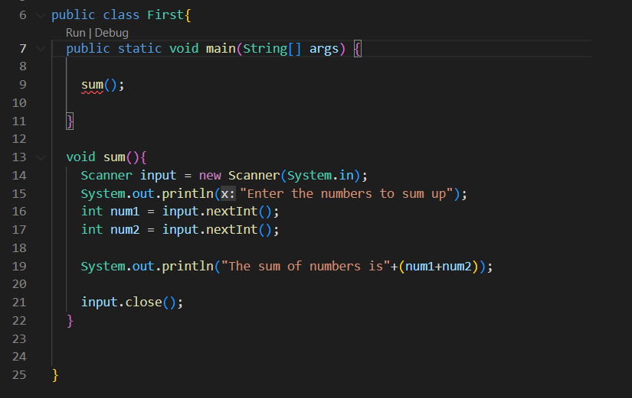

here we are trying to call the non static function from inside the static function which is not allowed

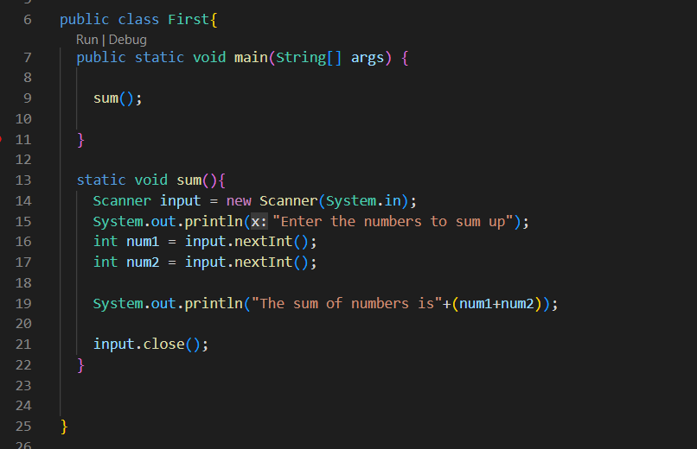

Now good

Note : In java there is no such thing as pass by reference like in C++. Becoz in java qwe do not have pointers, & or * operators

**Scoping in Java**

Function Scope : Variables defined inside the functions are available in that function only

Block scope : Variables defined inside any block are available inside that block only. We can not access those variables from outside the block

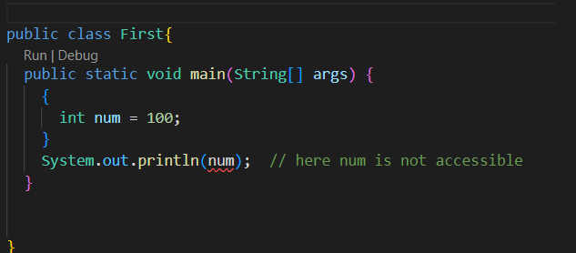

Loop scope : A loop has it’s own scope